37.Write a Pandas program to create a dataframe from a dictionary and display it.
Aim:
To write a Pandas program to create a DataFrame from a dictionary and display it.
Program:
import pandas as pd
data = {
'Name': ['Raj', 'Ravi', 'Sita', 'Anu'],
'Age': [20, 21, 19, 22],
'Marks': [85, 90, 88, 92]
}
df = pd.DataFrame(data)
print(df)
Output:
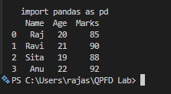
Result:
Thus, the Pandas program to create a DataFrame from a dictionary and display it was successfully executed.

38.Write a Pandas program to create and display a DataFrame from a specified
dictionary data which has the index labels.
Aim:
To write a Pandas program to create and display a DataFrame from a specified dictionary with index labels.
Program:
import pandas as pd
data = {
'Name': ['Raj', 'Ravi', 'Sita', 'Anu'],
'Age': [20, 21, 19, 22],
'Marks': [85, 90, 88, 92]
}
index_labels = ['A', 'B', 'C', 'D']
df = pd.DataFrame(data, index=index_labels)
print(df)
Output:
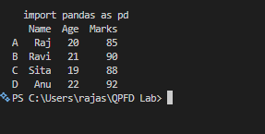
Result:
Thus, the Pandas program to create and display a DataFrame from a dictionary with specified index labels was successfully executed.

